[DEMO WEB SHOP](https://demowebshop.tricentis.com/)



**Test Plan Document**

**TEMPLATE**

| **Section** | **Description** |
| --- | --- |
| Objectives | What the testing aims to verify |
| Scope | What is and isn't included in testing |
| Methodology | How testing is done (Agile, CI/CD, etc.) |
| Assumptions | Conditions assumed before testing begins |
| Risks & Mitigation | Possible issues and how to handle them |
| Roles & Responsibilities | Who is doing what in the project |
| Schedule | Testing timeline and phases |
| Defect Tracking | How bugs are tracked and fixed |
| Environment | Tools, systems, and browsers used |
| Entry/Exit Criteria | When testing can start and finish |
| Test Automation | What’s automated and with what tools |
| Effort Estimation | Time and resources needed |
| Test Deliverables | Outputs produced during and after testing |

1. **TESTING OBJETIVES**
   * Verify user account features (registration, login, etc.).
   * Validate product search, browse, and filters.
   * Test cart, Wishlist, and checkout flows.
   * Ensure order placement and tracking.
   * Check UI usability and cross-browser/device support.
   * Verify data accuracy and integrity.
   * Validate security and access controls.
   * Test email alerts and backend systems.
   * Conduct performance and load tests.
   * Perform regression and error handling checks.
2. **SCOPE**

* Test user sign-up, login, and profile updates
* Check product search and filters
* Test cart, Wishlist, and checkout
* Verify payment and order confirmation
* Check email alerts (like order and signup)
* Test security and login access
* Check speed under heavy use
* Test on different browsers and devices
* Make sure errors and UI work properly

1. **AGILE BASED TEST METHODOLOGY**
   * Plan tests per sprint based on user stories.
   * Design modular test cases from acceptance criteria.
   * Set up test environments and data.
   * Execute tests continuously via CI/CD.
   * Report defects immediately.
   * Run regular regression tests.
   * Share test results in sprint reviews.
   * Improve process in retrospectives.

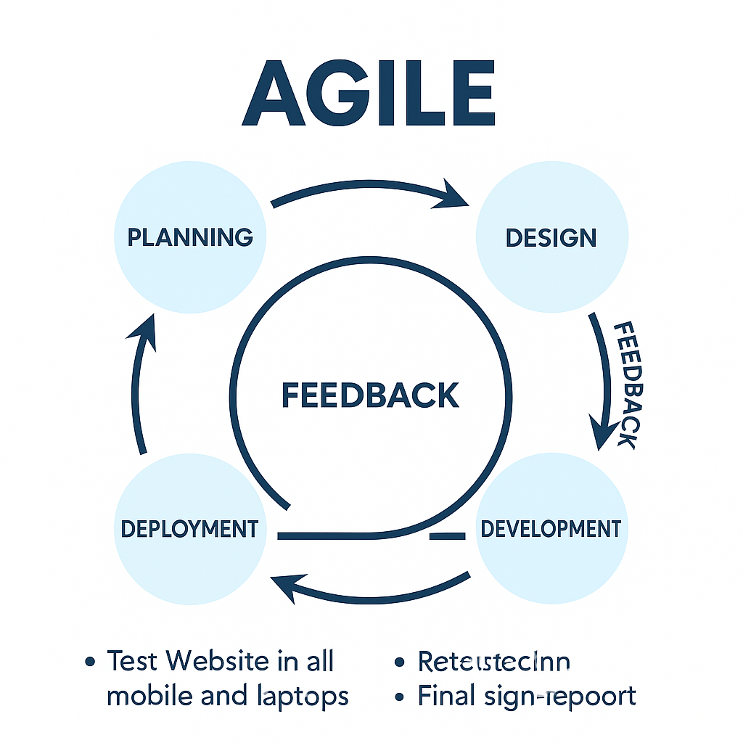

1. **ASSUMPTION:**

* All browsers, logins, and related services are functioning properly.
* Demo Web shop website, required test data and testing tools are ready for use.

1. **RISK:**

* Website can go down while testing.
* Data can lose or show wrong Information
* Some browser or devices may not work properly.
* Pages can load slowly.
* Payment’s failure
* Email or Order confirmation might not come.

1. **MITIGATION PLAN OR CONTINGENCY PLAN:**
2. **Mitigation Plan:**

* Test Website in all mobile and laptops
* Keep data and site backup ready.
* Check site speed and server working.

1. **Contingency Plan:**

* Use backup if site not working.
* Go back to last working site version.
* Fix big problems first.

1. **ROLES AND RESPONSIBILITY**

* **Test Manager:** Plans testing and checks progress, but **does not test the website.**
* **Tester:** Tests the website and reports bugs.
* **Developer:** Fixes the reported bugs.
* **Business Analyst:** Confirms requirements and clarifies doubts.
* **Project Manager:** Tracks overall work and project status.

1. **SCHEDULE:**

* **Test Planning:** Define strategy, scope, tools
* **Test Case Design:** Write test scenarios
* **Environment Setup:** Prepare tools and data
* **Test Execution:** Run tests and find bugs
* **Defect Retesting:** Fix and retest bugs
* **Test Closure:** Final report and sign-of

1. **DEFECT TRACKING:**

* **Tool:** Use tools like JIRA, Bugzilla to log and track bugs
* **Reporting:** Report bug with title, steps to reproduce, severity
* **Life Cycle:** Bug flow: New → Assigned → Fixed → Retest → Closed
* **Severity/Priority:** Classify bugs based on impact and urgency

1. **TEST ENVIRONMENT:**

* **Hardware:** Devices & specs (e.g., PC, mobile, RAM, CPU)
* **OS:** OS versions (e.g., Windows 11, Android 13)
* **Browsers:** Chrome, Firefox versions
* **Database:** MySQL, Oracle, etc.
* **Testing Tools:** Selenium, JIRA, Postman

1. **ENTRY AND EXIT CRITERIA**
2. **Entry Criteria:**

* Test cases are written, reviewed, and approved.
* Required test data is available and validated.

1. **Exit Criteria:**

* All planned test cases have been executed.
* Final test summary report is shared and approved.
* Stakeholders have provided formal sign-off for release.

1. **TEST AUTOMATION**

* **Goal**: Save time and effort by automating repeatable tasks.
* **Scope**: Automate login, product search, cart, checkout, and download verification.
* **Tools**: Selenium (UI testing), TestNG, Jenkins (CI/CD), and Extent Reports.
* **Approach**: Focus on high-use flows, use real test data, and run tests automatically after new builds.

1. **EFFORT ESTIMATION**

| **Task** | **Time Estimate(approx.)** |
| --- | --- |
| Test Planning | 3 hours |
| Test Case Design | 5 hours |
| Test Setup | 2 hours |
| Execution & Bug Logging | 10 hours |
| Retesting & Regression | 6 hours |
| Reporting & Closure | 2 hours |
| **Total** | **28 hours** (Approx. 3.5 days for 1 tester) |

1. **TEST DELIVERABLES**

* Test Plan Document
* Test Cases (manual/automated)
* Bug/Defect Reports
* Test Summary Report
* Automation Scripts
* Daily Status Reports
* Final Sign-off Document